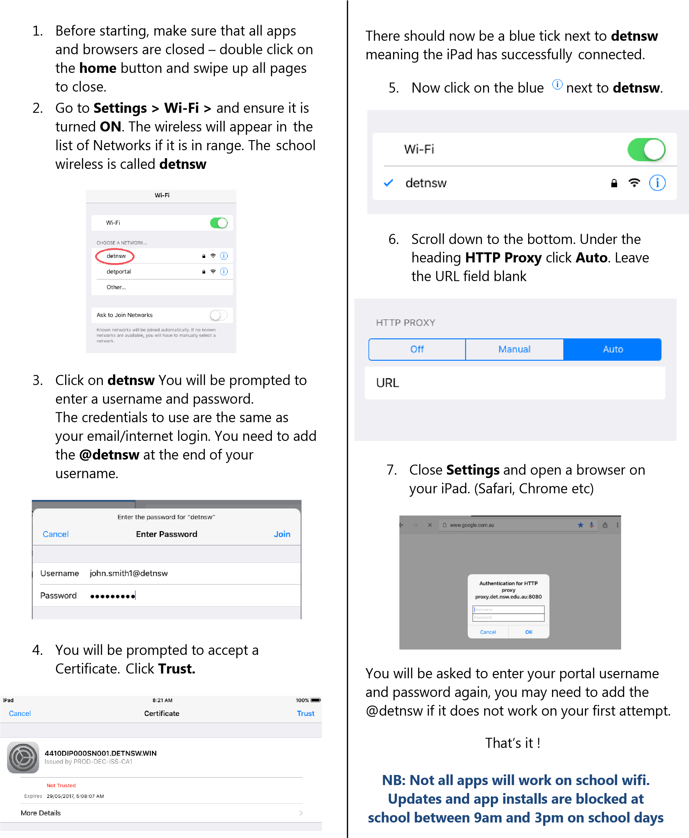
iPad’s
Windows 10

1. Before starting, make sure that all apps and browsers are closed.

2. Left click on the Wi-Fi symbol on the bottom right of the taskbar, circled below. This will bring up a list of Wi-Fi connection list. Click on the school connection detnsw and select connect.
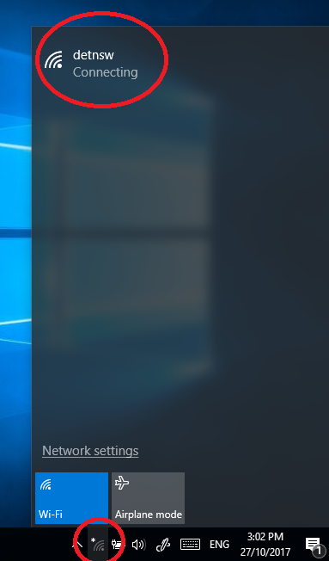

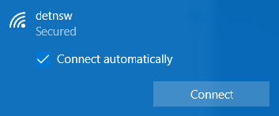
3. This prompt should appear click on Connect

4. You will be prompted to enter your credentials, they are the same as your
email/internet login. It will be your name and may have a number, in this format firstname.lastname5.
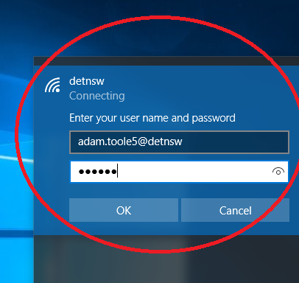At the end of your username you need to add @detnsw click OK.

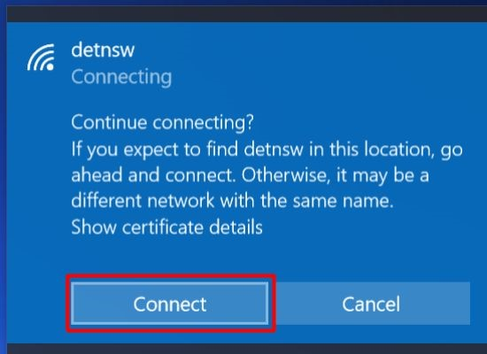
4. If everything goes right the window below will come up, hit connect

5. You may be prompted in Chrome or Windows to enter credential for proxy. This is the same details first.lastname5@detnsw

iOS/Mac

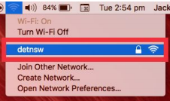
- Click on the Wi-Fi symbol at the top right and click on detnsw

- You will be prompted to enter your credentials, they are the same as your email/internet login. It will be your name and may have a number in this format firstname.lastname5 click on Join.
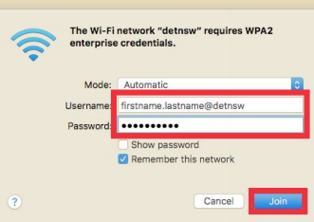

- Once you have joined the Wi-Fi you need to set the proxy settings. Click on the Wi-Fi symbol and select Open Network preferences
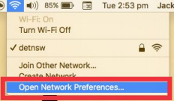

- Click on Advanced button.
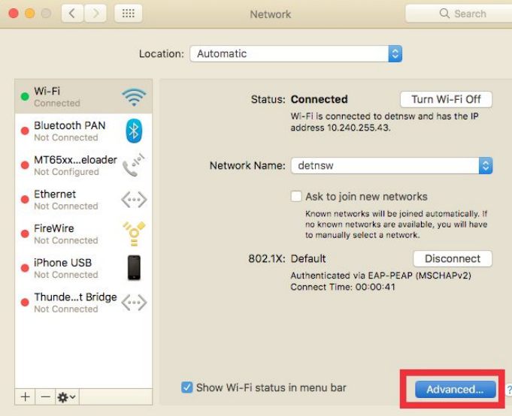

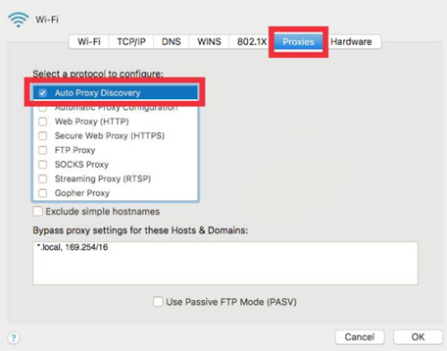
- Click on the Proxies tab and tick on Auto Proxy Discovery and click Ok

- The Network Preferences window will come up and click Apply and close the window.
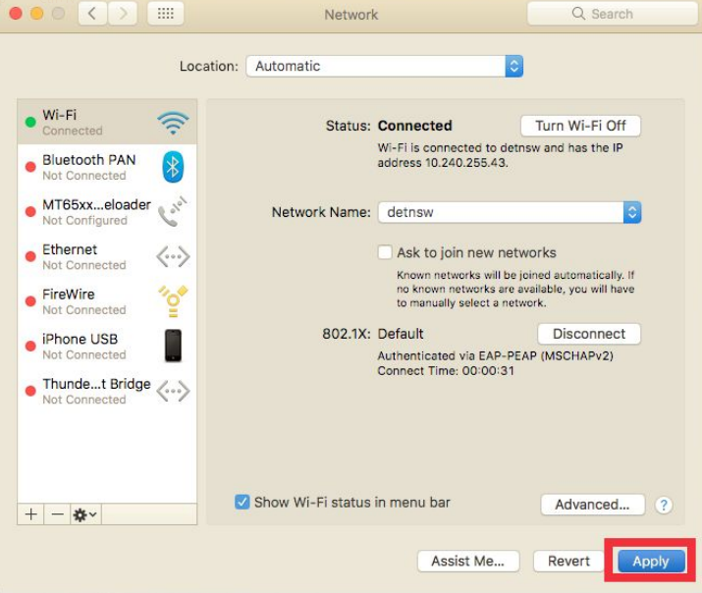

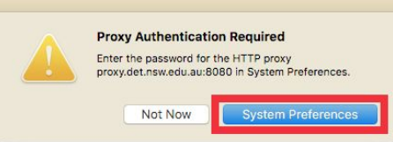
- When you open Safari you will be asked for Proxy Authentication. Click “System Preferences” if it appears

- Enter your username and password, remember to add @detnsw
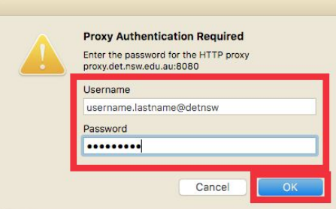

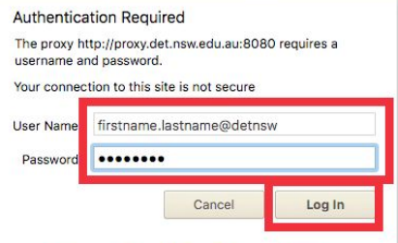
- If you use Chrome a similar prompt will come up and you need to enter the same details.

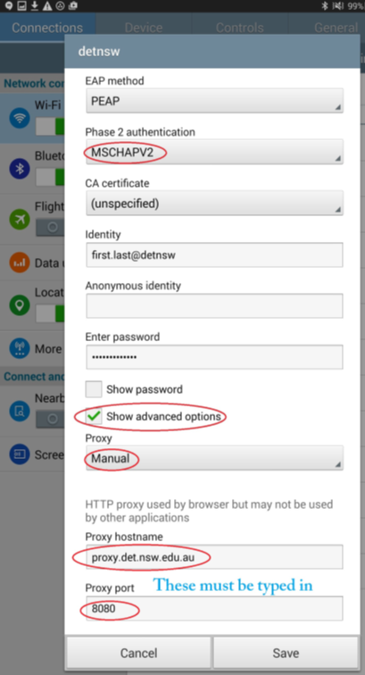
Android

1.Go to Settings > Network and Internet > Wi-Fi

2. Select DETNSW and the screen to the right will appear in some style depending on your phone version.

3. Match the settings on the right EAP Method should be set to PEAP, the Phase 2 authentication is MSCHAPV2 and leave CA certificate or turn it to Do not validate

4. Your identity will be the same as your email/internet login. You need to add @detnsw at the end of your username first.last@detnsw

5. Select Proxy settings > Manual type in proxy.det.nsw.edu.au and set the port number 8080 and Save

6. Open your browser and if it may request your proxy login it’s the same username and password, remember to add @detnsw.

