Cold Food
Chicken Lettuce Mayo Roll | Small | $2.00
Chicken Lettuce Mayo Roll | Large | $4.00
Salad Roll | Small | $2.00
Salad Roll | Large | $3.50
Cheese Salad Roll | Small | $2.00
Cheese Salad Roll/Wrap | Large | $4.00
Chicken Cheese Carrot Lettuce Wrap |  | $5.00
Ham Cheese Tomato Sandwich |  | $3.50
Egg Lettuce Sandwich |  | $2.50
Egg Sandwich |  | $2.00
Egg Cheese Sandwich |  | $2.50
Vegemite Sandwich |  | $2.00
Cheese Sandwich |  | $2.00
Jam Sandwich |  | $2.00
Make Mine Toasted |  | Add $.50c
GF available on Request
Garden Salad | Small | $3.00
Garden Salad | Large | $4.50
Greek Salad | Small | $3.00
Greek Salad | Large | $4.50
Sushi: (twice per term): Tuna, Salmon, Teriyaki, Schnitzel | Wednesday Only | Prices Vary
Caesar Salad | Small | $3.00
Caesar Salad | Large | $4.50
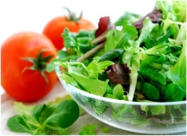

Breakfast Special
- Free toasting of sandwiches made on site
- Toast, butter and spread only $0.50c a slice
- English muffins/Crumpets $1.00
- Fruit Toast $0.50c a slice

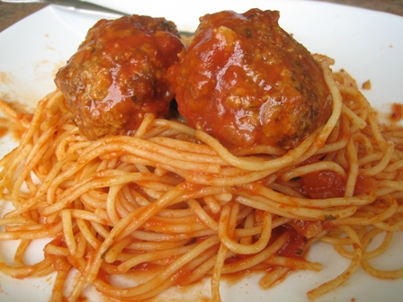

Hot Food
Chicken Curry | $6.50
Vegetarian Curry | $5.50
Chicken Noodle Cuppa Soup | $1.50
Cuppa Soup 2 varieties | $1.50
Pumpkin Soup subject to availability | $3.00
Pizza Subs Tuesdays Only | $1.50
Pasta and Meatballs Wednesdays Only | $3.50
Vegetarian Pasta Wednesdays Only | $3.00
Chicken Burger Mondays Only | $3.50
Sweet Chilli Chicken Tender Wraps Thursdays Only | $4.00
Chicken Chippies Fridays Only | $2.00
Pie | $3.50
Sausage Roll | $3.00
Potato Pie | $3.50
Cheese and Bacon Pizza | $3.00
Use our “Make Your Own”
Order Form

Hot Food by Order Only
Tomato Soup | $2.00
Toasted Ham Cheese Tomato Sandwich | $4.00
Toasted Ham Cheese Sandwich | $3.50
Toasted Chicken Cheese Sandwich | $4.00
Toasted Cheese Tomato Onion Sandwich | $3.50
Toasted Cheese Sandwich | $2.50
Toasted Tuna Cheese Sandwich | $4.00
Spaghetti Toastie | $3.50
Baked-Bean Toastie | $3.50
Make mine a Toasted Wrap | Add $.50c
Poached Egg on Toast | $1.00
Mac and Cheese | $3.50
Breakfast items: Toast, Crumpets, English Muffins, Fruit Toast available all day
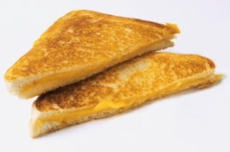
Drinks
Water | 600ml | $1.00
Water | 750ml | $3.00
Raspberry Water | 750ml | $3.00
Lime Cucumber Water | 750ml | $3.00
Blood Orange Water | 750ml | $3.00
Hot Chocolate by order only | 250ml | $2.00
Sparkling Mineral Water Berry | 500ml | $3.00
Plain Milk | 300ml | $1.00
Plain Milk | 600ml | $2.00
Plain Milk | 1lt | $2.50
Chocolate Milk | 300ml | $2.00
Strawberry Milk | 300ml | $2.00
Banana Milk | 300ml | $2.00
Vanilla Malt Milk | 300ml | $2.00
Oak Plus Chocolate | 500ml | $3.50
Oak Plus Vanilla Malt | 500ml | $3.50
Zymil Lactose Free Chocolate | 400ml | $3.50
Zymil Lactose Free Strawberry | 400ml | $3.50
Farmhouse Gold Chocolate | 300ml | $3.00
Oak Thick Chocolate | 500ml | $3.50
Oak Thick Vanilla | 500ml | $3.50
Iced Coffee | 300ml | $2.00
Oak Plus Iced Coffee | 500ml | $3.50
Pepsi Max | 375ml | $2.00
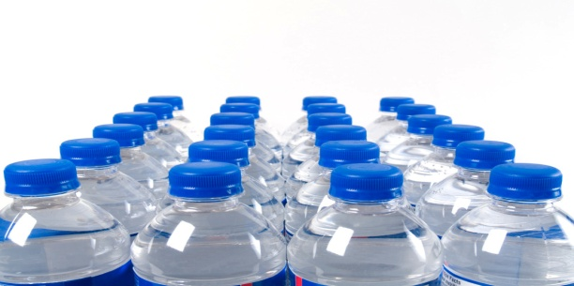  Pepsi Max Vanilla | 375ml | $2.00
Sugar Free Solo | 375ml | $2.00
Sugar Free Raspberry | 375ml | $2.00

Snacks
Mixed Veg Sticks | $.50c
Celery Sticks | $.50c
Carrot Sticks | $.50c
Dip: Hummus Tzatzki Salsa French Onion | $.50c
Cheese Cubes | $.50c
Crackers (6) | $.50c
Cruskits subject to availability | $.50c
Veg and Dip | $1.00
Yoghurt and Berries | $2.00
Muesli Cups | $.50c
Watermelon Cups Small | $1.00
Watermelon Cups Large | $1.50
Fruit Salad | $2.00
Rockmelon Tubs | $1.50
Pineapple Tubs | $1.50
Apple | $.50c
Orange | $.50c
Banana | $.50c
Hardboiled Egg | $.50c
Custard Cups | $2.00
Sultanas | $.50c
Apricots | $.50c
Dates | $.50c
Popcorn | $1.00
Honey Soy Chicken Chips | $1.00
Sea Salt Chips | $1.00
BBQ Snaps | $1.50
Grain Waves | $1.00
Fruit Muffins | $1.00

Frozen Treats
Quelch Stick 5 Assorted Flavours | $.50c
Apple Fruit Cup | $1.00
Orange Fruit Cup | $1.00
ABC Fruit Cup | $1.00
Juicies 4 Assorted Flavours | $1.00
Ice Mony Blue Raspberry | $1.00
Ice Mony Chocolate | $1.00
Ice Cream cups | $1.50
Chocolate Moosie | $1.00
Blue Moosie | $1.00

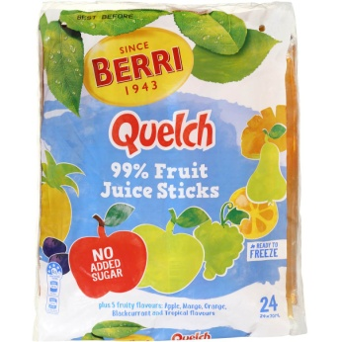

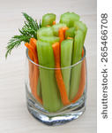

- All prices are subject to change
- New Volunteers are always welcome
- Contact Tanya McCauley
- 02 4261 1416

